The central design decision: NEXUS should accept a task quickly, execute it asynchronously, and expose durable status and results through the API. A single HTTP request should not remain open while a long-running computer task executes.

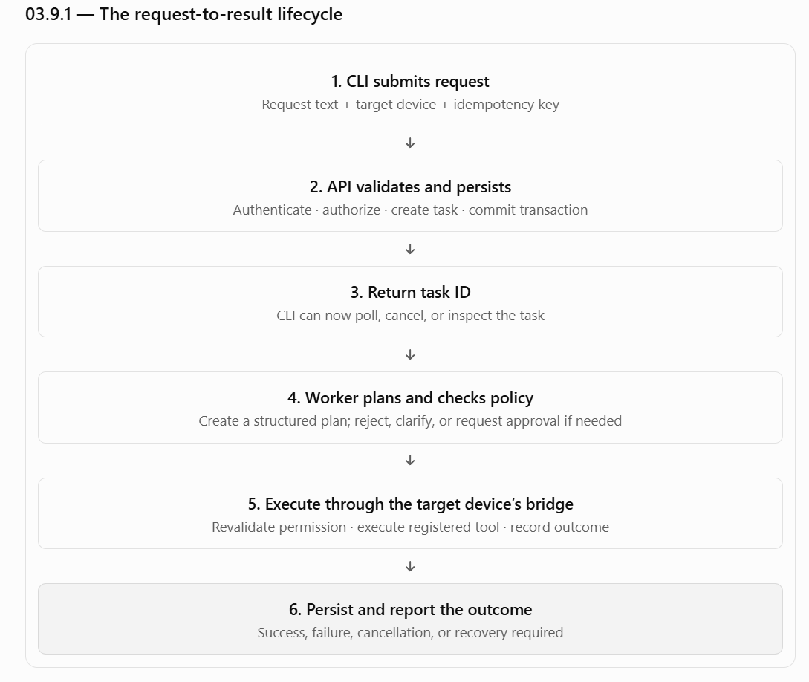

03.9.1 — The request-to-result lifecycle

03.9.2 — Proposed API contract
The following routes are a starting proposal. Exact names, schemas and authentication mechanics remain open until the API contract is reviewed.
Method | Proposed route | Purpose
POST | /v1/tasks | Submit a task
GET | /v1/tasks/{task_id} | Get status and summary
GET | /v1/tasks/{task_id}/steps | Inspect step-level progress
POST | /v1/tasks/{task_id}/approvals/{approval_id} | Approve or reject a pending operation
POST | /v1/tasks/{task_id}/cancel | Request cancellation
GET | /v1/tasks/{task_id}/result | Retrieve final or partial results
GET | /v1/tasks | List tasks visible to the authenticated user
The API must enforce authorization on every request. Knowing a task ID must not grant access to that task.

Example: task submission
Illustrative request:
{
"request": "Find the design documents in my project folder",
"target_device_id": "device-123",
"client_request_id": "unique-request-id"
}
The client_request_id is generated by the CLI and reused if the client retries the same submission. The backend must scope it to the authenticated user and apply a uniqueness constraint so that a network retry does not create a second task.
Illustrative response:
{
"task_id": "task-456",
"status": "queued",
"accepted": true
}
These identifiers and fields are examples, not a finalized schema.
Important: the target device is explicit. If device-123 is offline, NEXUS must not silently execute the task on the host computer or another teammate’s device.

03.9.3 — Synchronous versus asynchronous execution
NEXUS needs both synchronous API responses and asynchronous task execution. These are not competing designs; they serve different purposes.
Synchronous API operations
Return a response once the short operation is complete.
- Authenticate the caller.
- Validate request structure.
- Read task status.
- Submit an approval or cancellation request.
Asynchronous task execution
Continue independently after the API accepts the task.
- Plan a multi-step operation.
- Wait for user approval.
- Search files or read documents.
- Communicate with a Windows bridge.
- Recover from interruptions and verify results.

Proposed execution rule
- The API validates and persists a task.
- The API returns a task ID after the transaction commits.
- A worker claims the task and starts processing it.
- The CLI retrieves progress using the task ID.
- The task reaches a terminal state, or an explicit recovery state if the outcome is uncertain.
The API must not hold a database transaction open throughout the entire task. Long-running work can take seconds or minutes, and a transaction spanning that work would increase lock duration and complicate recovery.
Initial implementation recommendation: start with a worker process inside the modular backend, using PostgreSQL for durable task coordination. Add a separate queue technology only if measured requirements justify it.
A background task tied only to the lifetime of an HTTP request is not sufficient for durable execution.

03.9.4 — Task state machine
The state machine defines what the API reports and which transitions are legal.
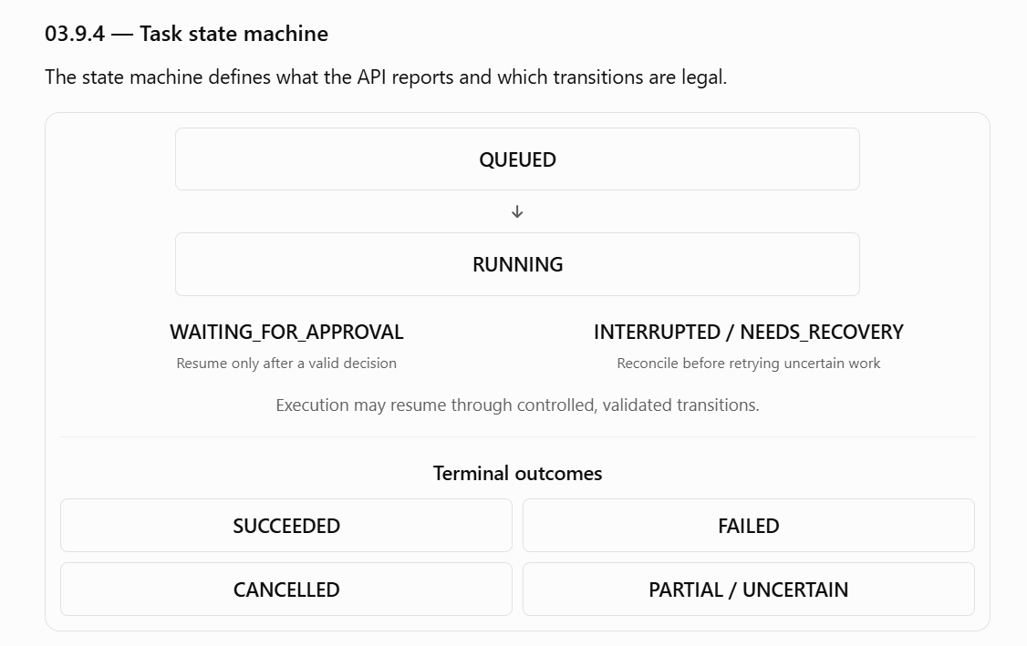This diagram is conceptual. The exact state names and transition table need to be finalized together in the execution-state-machine section.

Key distinctions:
- Failed: NEXUS knows the task did not complete successfully.
- Interrupted: execution was disrupted; the final outcome may not yet be known.
- Needs recovery: a step requires reconciliation or a deliberate recovery decision.
- Cancelled: NEXUS has verified that execution stopped safely.
- Partial success: some steps completed, while others failed or remain uncertain.
Partial success is likely better represented as a result classification alongside a terminal task state, rather than as an additional state mixed into the state machine. We should validate that choice during the state-machine design.

Transition invariants
- Every transition must be validated by application code.
- Every accepted transition must be persisted.
- A worker must not execute a task already claimed by another worker without a valid ownership mechanism.
- Approval does not automatically imply that execution is still authorized; permissions must be checked again before execution.
- A task cannot become SUCCEEDED merely because the model returned a plan. Required operations and verification must have finished.
- If the backend restarts, it must recover from persisted state rather than assuming every task was either completed or never started.

03.9.5 — Idempotency and duplicate prevention
NEXUS operates across HTTP, PostgreSQL, and a separate Windows process. A timeout can occur even when an operation succeeded. This is one of the most important reliability problems in the system.
Consider this sequence:
- The bridge receives a request to create a file.
- The file is created.
- The bridge sends a success response.
- The network connection drops before the backend receives it.
- The backend sees a timeout.
At step 5, NEXUS does not know whether the file was created. Blindly repeating the operation could create a duplicate or overwrite existing content.
We need two distinct kinds of idempotency.

A. Task-submission idempotency
The CLI supplies a stable request identifier.
- First submission: create the task and store the identifier.
- Retry with the same identifier and same request: return the existing task.
- Reuse the identifier with different request content: reject it as a conflict.
- A new deliberate user submission: use a new identifier.
A database uniqueness constraint should enforce this, not just a check in Python. The check and insert must be protected against concurrent duplicate submissions.

B. Operation-level idempotency
Every executable step receives a stable operation identifier. The backend reuses that identifier when retrying the same logical operation.
The bridge should maintain a durable operation record where practical, and the operation handler must be designed around the specific tool's behavior.
Operation | Retry approach
Search permitted files | Generally safe to retry
Read a document | Generally safe to retry, subject to file changes
Create a new file | Check operation identity and destination state before retry
Overwrite a file | Require appropriate authorization and verify the expected file state
Launch an application | May launch duplicate instances; define tool-specific behavior
Move or delete a file | Reconcile actual filesystem state before retrying
Do not promise “exactly-once execution” across the backend and Windows bridge. A database transaction cannot atomically commit a filesystem change on another computer. NEXUS must use durable identifiers, safe retries, reconciliation and explicit uncertainty handling instead.

03.9.6 — Database consistency versus real Windows operations
PostgreSQL can atomically update NEXUS records. It cannot atomically commit a file operation performed on a teammate’s Windows computer.
This creates a distributed consistency boundary.

Proposed step execution protocol
For each operation:
- Prepare: validate the task, target device, tool arguments and current permissions.
- Persist intent: record the step as ready for execution, with its stable operation ID.
- Claim: ensure only one valid worker owns the step at a time.
- Dispatch: send the operation to the correct registered bridge.
- Execute: the bridge validates the request against its own local policy and executes the registered tool.
- Record outcome: persist the bridge's structured response and update the step state.
- Verify: when appropriate, inspect the resulting state rather than trusting a response alone.
The intent record means NEXUS can tell that an operation was about to be attempted. It does not prove the operation actually happened.

What if the process crashes?
Failure point | Required behavior
Before intent is committed | The step must not be dispatched
After intent, before dispatch | Reconcile the step and dispatch if safe
During dispatch, before a response | Mark the outcome uncertain until reconciled
After Windows changes state, before outcome is persisted | Inspect the real state before retrying
After outcome is persisted | Resume from the next eligible step, not from the beginning
This is a design target, not a guarantee that every action can always be reconciled. Some operations may require manual intervention.

Example: creating a report
Suppose NEXUS creates report.txt and the bridge disconnects before confirming success.
The backend should not immediately create the file again. It should use the operation ID and inspect the destination. If the file exists, it must establish whether it corresponds to the attempted operation before marking the step successful. If that cannot be established reliably, it should report an uncertain outcome.
This also means file tools need explicit overwrite policies and should not silently replace existing content.

03.9.7 — Concurrency and worker ownership
Three developers using NEXUS simultaneously is a normal operating condition, not an edge case.
The design must prevent duplicate execution and cross-user access while still allowing independent tasks to proceed.

Proposed concurrency rules
- Multiple users may submit tasks concurrently.
- Independent devices may execute tasks concurrently, subject to configured limits.
- Each task belongs to one authenticated user and has one explicit target device.
- A device may have a configurable maximum number of active operations.
- By default, operations that could conflict on the same resource should be serialized or guarded by resource-specific coordination.
- A worker claim must have an owner, an expiry or lease mechanism, and a way to prevent a stale worker from committing state changes after losing ownership.
- A worker must not hold a PostgreSQL transaction open while waiting for a Windows operation to finish.

Worker claims and stale ownership
A basic status = 'running' field is insufficient. Two workers could both read a task as eligible and execute it simultaneously.
A suitable design will need an atomic claim mechanism—for example, a transaction using row-level locking and a claim token, or another validated PostgreSQL-based coordination approach.
If a worker's lease expires, another worker must not assume it is safe to repeat the Windows operation. It must first determine whether the previous worker dispatched the operation and whether the bridge executed it.
The precise locking approach, lease duration, worker count and connection-pool sizing remain implementation decisions.

03.9.8 — Approval, cancellation and progress

Approval
An approval must be bound to the exact operation that the user reviewed.
The approval record should identify:
- The task and step.
- The requesting user and target device.
- The operation and its validated parameters, or a stable representation of them.
- The approving identity and decision.
- Creation and expiry times.
- The final execution status.
If the operation parameters change after approval, the old approval must not authorize the changed operation.
A rejected or expired approval must not be executed. The API should return the updated task status after the decision has been persisted.

Cancellation
Cancellation is a request to stop—not proof that work has stopped.
Proposed behavior:
- Authenticate and authorize the cancellation request.
- Persist the cancellation request.
- Signal the worker and, where applicable, the bridge.
- Stop before dispatching additional operations when possible.
- Determine the outcome of any operation already in flight.
- Mark the task cancelled only after the required stopping conditions are verified.
If an operation has already changed the filesystem, cancellation does not automatically roll it back. NEXUS must report completed work and any remaining uncertainty.

Progress
Progress should be based on persisted events or step state, not just text generated by the model.
An illustrative progress response:
{
"task_id": "task-456",
"status": "running",
"current_step": 2,
"completed_steps": 1,
"total_steps": 3,
"message": "Reading the matching documents"
}
The number of steps may change during planning, so total_steps can be unknown initially. Progress must never be fabricated merely to make the interface appear active.
For the first version, polling GET /v1/tasks/{task_id} is adequate. Server-sent events or WebSockets can be considered later if polling creates measurable overhead or an unacceptable user experience.

03.9.9 — Results, errors and observability
A task response should distinguish between the task's lifecycle status and its actual result.
For example, an operation may have completed three steps, failed on the fourth, and left the fifth unattempted. The result must preserve that information.

Proposed result structure
{
"task_id": "task-456",
"status": "failed",
"outcome": "partial_success",
"completed_steps": 3,
"failed_step": {
"step_id": "step-4",
"error_code": "DEVICE_OPERATION_FAILED",
"message": "The requested document could not be read."
},
"uncertain_steps": [],
"next_action": "Review the failed step and retry if appropriate."
}
This is illustrative, not the final response schema.

Error categories
Category | Example | Expected behavior
Validation | Missing required input | Reject the request before execution
Authentication | Invalid credentials | Deny access
Authorization | User cannot access the target device | Deny access and audit appropriately
Conflict | Duplicate request ID with different content | Return a conflict response
Device unavailable | Bridge disconnected | Wait, fail or interrupt according to policy
Tool failure | Document cannot be read | Record the failed step and explain why
Uncertain outcome | Connection lost during file creation | Reconcile before retry
Internal failure | Unexpected backend error | Return a stable error ID; keep sensitive details out of client responses
Every error should have a stable machine-readable code and a clear human-readable message. Logs should carry correlation identifiers, but must not contain credentials, tokens or unnecessary private document content.

03.9.10 — API acceptance criteria
The following tests should be required before this section is considered implemented.

Implementation review checklist
0/20 reviewed
Task submission
A valid request creates a durable task and returns its ID.
A retry with the same request ID does not create a duplicate task.
Reusing a request ID with different content is rejected.
A failed database commit never produces a false acceptance response.
Ownership and device routing
A user cannot read, approve or cancel another user's task.
An offline target device is never silently replaced with another device.
A revoked device cannot execute new operations.
A stale worker cannot overwrite a newer worker's task state.
Execution and recovery
A long-running task does not require the original HTTP request to remain open.
A crash before dispatch does not lose the persisted task.
A timeout after dispatch triggers reconciliation before an unsafe retry.
Restarting the backend does not blindly replay every running task.
Approval and cancellation
An expired or rejected approval cannot authorize execution.
Changing approved operation parameters invalidates the prior approval.
Cancellation prevents additional operations when safely possible.
An in-flight operation is reconciled before the task is marked cancelled.
Results and observability
Partial results identify completed, failed and uncertain steps.
Errors have stable codes and useful messages.
Progress is derived from actual task state.
Logs contain enough correlation data for diagnosis without leaking secrets.

03.9.11 — Decisions to carry into detailed design
These decisions are proposed defaults, not frozen implementation requirements.
Decision | Proposed direction
Long-running tasks | Asynchronous
Initial progress interface | HTTP polling
Task durability | PostgreSQL
Duplicate submission prevention | Client request ID + database uniqueness
Step retry prevention | Stable operation IDs + tool-specific reconciliation
Worker coordination | PostgreSQL-backed atomic claims initially
Task ownership | Authenticated user + explicit target device
Permission enforcement | Backend policy plus independent bridge validation
Disconnect handling | Persist uncertainty; reconcile before unsafe retry
Recovery | Resume only from validated persisted state
Queue technology | Do not introduce a separate broker until justified

